EXP-10

NAME- Jayesh Mahajan

ROLL NO-11

PRN NO-1032220100

CREATE PIVOT TABLE

ASSIGNMENT 1:

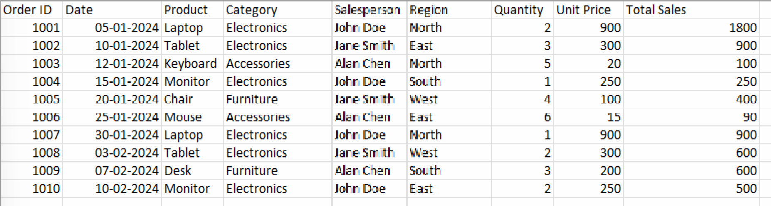

**Total Sales by Region and Salesperson:**

1.Create a Pivot Table to display the Total Sales for each Region, broken down by Salesperson.

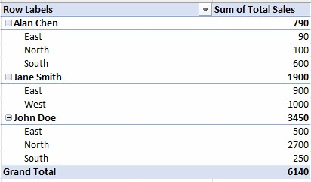

2. Which region has the highest total sales, and which salesperson contributed most to that?

The region with the highest total sales is North, with a total of $2800. The salesperson who contributed the most to this is John Doe.

**Average Unit Price by Product Category:**

1 .Create a Pivot Table to calculate the Average Unit Price for each Category.

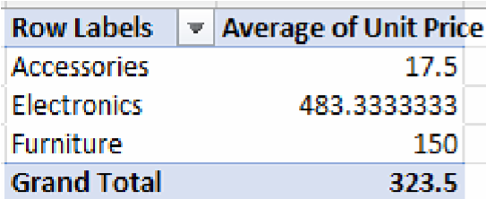

2 . Which product category has the highest average unit price?

The product category with the highest average unit price is Electronics, with an average unit price of $483.33.

**Total Quantity Sold by Product:**

1 . Create a Pivot Table that shows the Total Quantity sold for each Product.

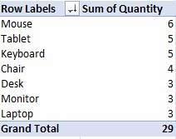

2 .Which product had the highest number of units sold?

The product with the highest number of units sold is Mouse.

**Sales Over Time:**

1. Create a Pivot Table that summarizes Total Sales for each month.

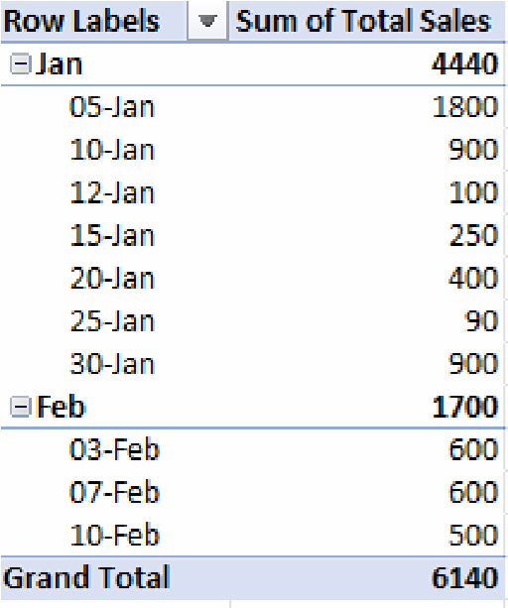

1. What are the total sales for January and February? The total sales for January and February are $4440 and $1700 respectively.

**Top Salesperson by Total Sales:**

1 .Create a Pivot Table to show the Total Sales for each Salesperson.

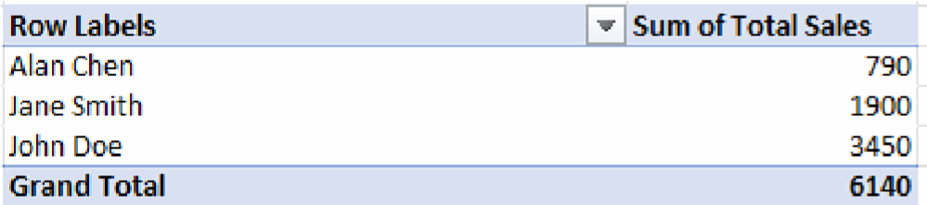

2 . Who is the top-performing salesperson based on total sales?

The top-performing salesperson based on total sales is John Doe.

ASSIGNMENT 2:

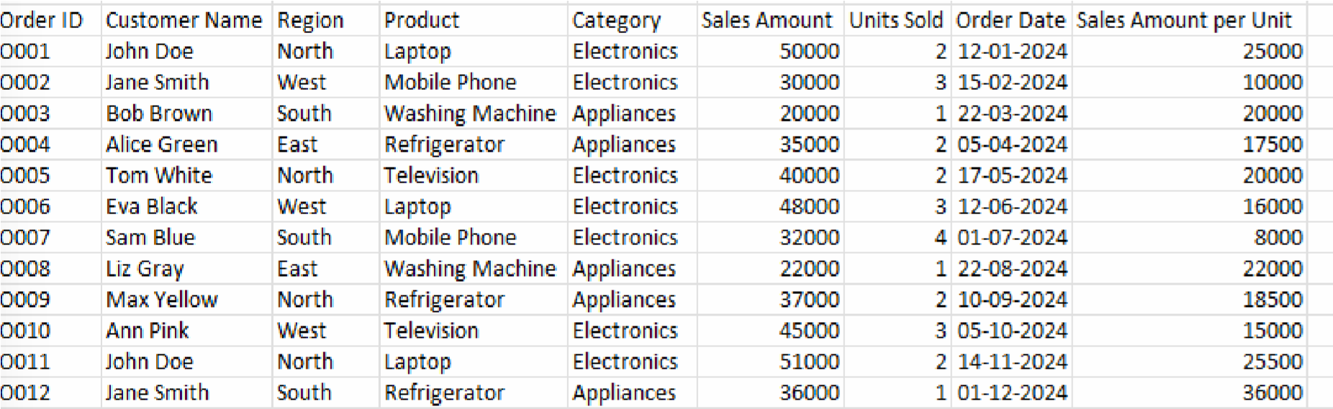

**Create a Pivot Table to Summarize Sales by Region:**

1 .Create a pivot table showing the total Sales Amount by Region.

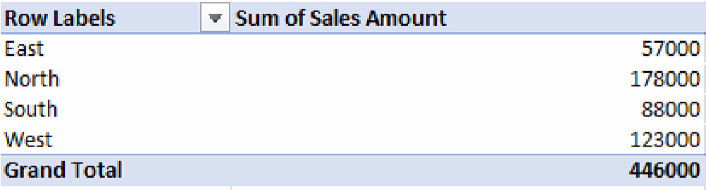

2 . Which region has the highest total sales?

The North region has the highest total sales, with a total Sales Amount of 178,000.

**Summarize Sales by Product and Region:**

1 .Build a pivot table that summarizes the Sales Amount by Product and Region.

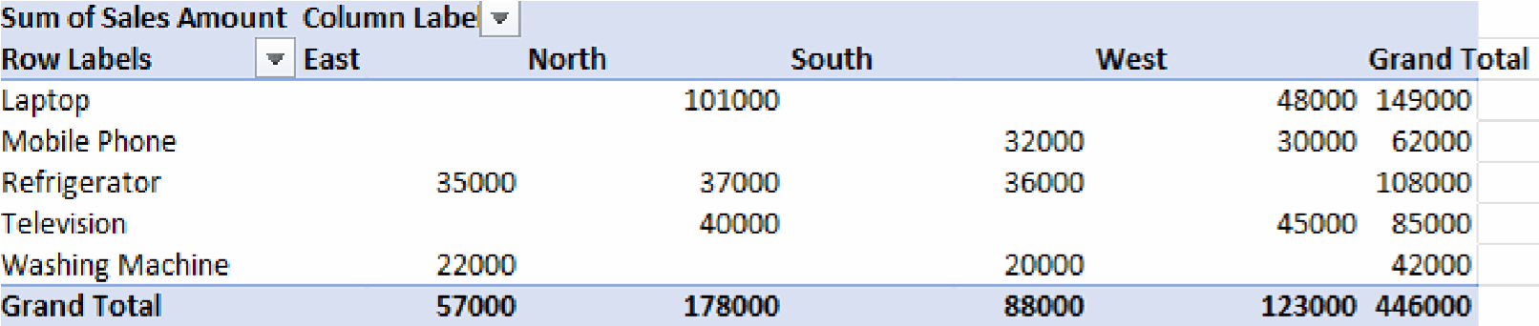

2 . Which product had the highest sales in the West region?

The product with the highest sales in the West region is laptop.

**Analyze Sales by Category and Units Sold:**

1.Create a pivot table that shows the total Units Sold for each Category (Electronics, Appliances).

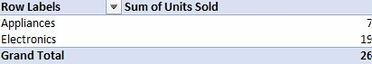

2 . How many total units of Appliances were sold? The total units of Appliances sold is 7.

**Filter Pivot Table by Date:**

1.Build a pivot table that summarizes total Sales Amount by Month. Use the Order Date to group by month.

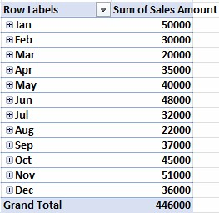

2 . Which month had the highest sales?

The month of November has the highest sales.

**Analyze Average Sales per Unit by Product:**

1.Create a pivot table showing the Average Sales Amount per Unit for each Product.

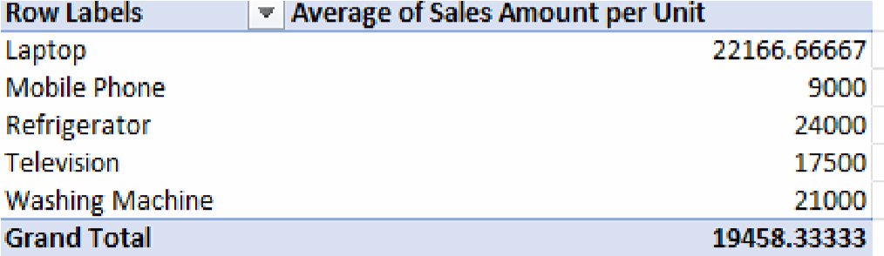

2 . Which product has the highest average sales per unit?

The product with the highest average sales per unit is Refrigerator.

**Create a Pivot Table to Find Top Customers by Sales:**

1 .Create a pivot table that summarizes total Sales Amount by Customer Name.

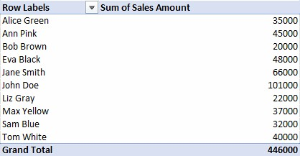

2 . Who are the top 2 customers by total sales?

The top 2 customers by total sales are John Doe and Jane Smith.

**Show Sales per Region and Product with a Slicer:**

1 .Create a pivot table that shows Sales Amount by Product for each Region. Add a slicer for Region so that you can filter the pivot table by region.

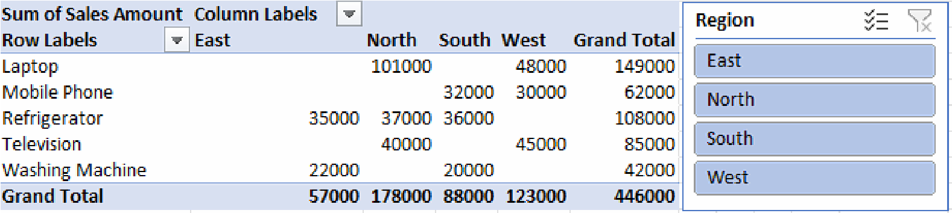

2 . When filtering by the North region, which product has the highest Sales?

The product with the highest sales is laptop.

**Count of Orders by Product and Category:**

1 .Build a pivot table that shows the Count of Orders by Product and Category.

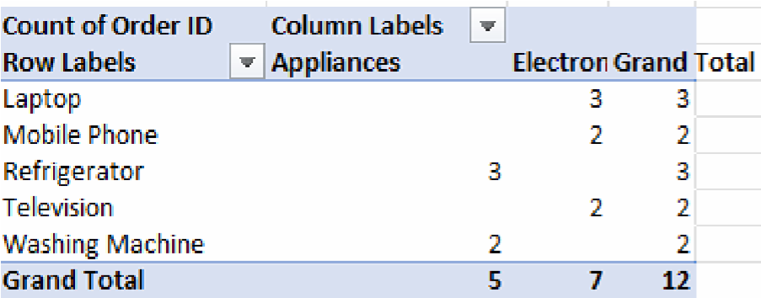

2 . Which product in the Appliances category has the most orders? The product in the Appliances category with the most orders is Refrigerator.

**Analyze Sales Growth:**

1 .Create a pivot table that summarizes total Sales Amount by Month.

Add a percentage change column in the pivot table to show the sales growth monthover-month.

